Transcript
Revision - Listening skills and strategies
Practice 1.
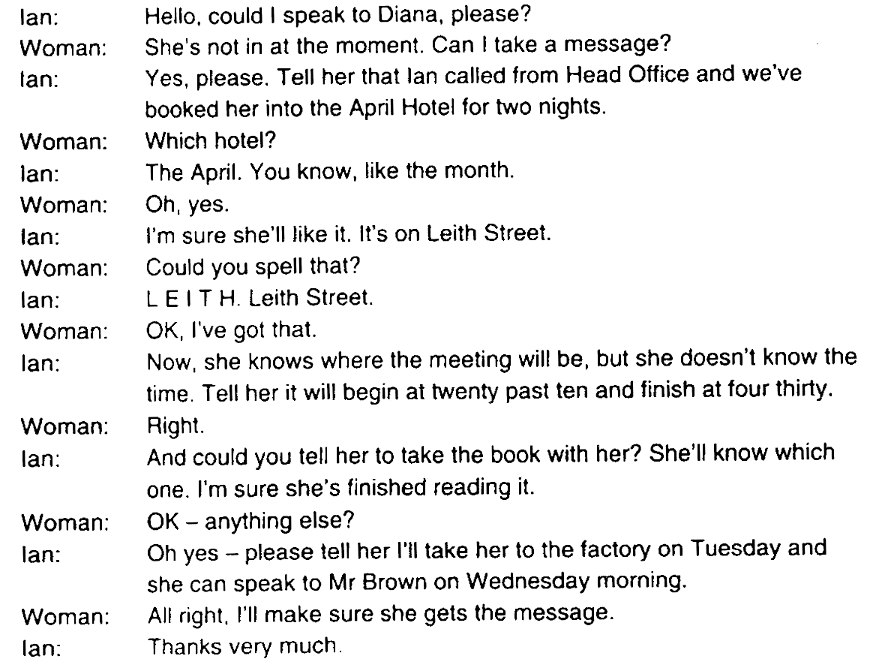
Practice 2.
1. Griffith invented an inexpensive system for making eyeglasses and a giant, 3,000-square-foot kite that can produce electricity. He says that do-it-yourself brings people closer to the objects they own. They get involved emotionally with the things around them.
2. Griffith and some colleagues created Howtoons to pass this idea on to today's kids. Howtoons is a cartoon series that helps kids learn to think like inventors. Kids can find Howtoons online or buy the cartoons in book form.
3. With the help of Howtoons, kids use soda bottles to create rockets or to make waterscopes for looking at objects under water. They can learn to make their own pens, paper, and ink and to create many other interesting things.
Practice 5.
— Are you almost finished with your report, Min Hee?
— Not yet. I have to finish by it by Friday. I’m doing research now.
— I can see you working hard. What’s the report about?
— It’s about the science of facial expressions, for example, smiling. I’m studying why we smile and what it means when we smile.
— Science of facial expressions — interesting. Don’t we just smile when we think something is funny?
— Not just that. A smile can have many meanings. It’s an important way that we communicate without words. A smile shows we are friendly. It helps us make connections with others
— That makes sense. I like people who smile a lot
— Well, research shows that women smile more often than men and a happy person smiles about 40 to 50 times a day.
— I know smiling is important in professional situations. I work at the central hotel. My boss says that a smile should be the first thing our customer see
— Well 28% of people say they smile more than 20 times in a day at work.
— I’m sure I smile more than that.
— Can you imagine being unable to smile?
— No way
— So what’s the topic of your report, Ivan?
— It’s about how we express our opinions and ideas when we’re speaking. Especially when it’s something that people disagree about.
— That sounds really interesting.
— I think so. For example, when we have a discussion or a debate about an important topic, we sometimes feel strong emotions.
— That’s true. When other people don’t understand or agree with our ideas they may feel a little angry
— Right and during a discussion when we express these emotions with our facial expressions or body language it can send the wrong message. It’s bad for communication
— Interesting. I know a lot of people feel nervous when they speak too.
— That’s true. About 75% of people feel nervous about speaking. My report describes ways we can stay calm and use our faces our bodies and our voices to communicate our ideas more clearly
— Wow, I really wanna read that.

